**Project 2**

**Extra credit (Runner animation)**

**Link:** [**http://eecs.csuohio.edu/~evbenite/Proj2/**](http://eecs.csuohio.edu/~evbenite/Proj1/)

**index.htms**

<?xml version="1.0" encoding="UTF-8"?>

<!DOCTYPE html PUBLIC "-//W3C//DTD XHTML 1.1/EN"

"http://www.w3.org/TR/xhtml11/DTD/xhtml11.dtd">

<html xmlns="http://www.w3.org/1999/xhtml">

<head>

<title>Project 2</title>

<link type="text/css" href="p2.css" rel="stylesheet" />

<link rel="stylesheet" href="https://maxcdn.bootstrapcdn.com/bootstrap/3.4.1/css/bootstrap.min.css" />

<script type="text/javascript" src="https://ajax.googleapis.com/ajax/libs/jquery/3.5.1/jquery.min.js"></script>

<script type="text/javascript" src="https://maxcdn.bootstrapcdn.com/bootstrap/3.4.1/js/bootstrap.min.js"></script>

<script type="text/javascript" src="p2.js"></script>

</head>

<body onload="startSlides()">

<!-- tab section -->

<div class="container">

<ul class="nav nav-tabs">

<li class=" active"><a data-toggle="tab" href="#home">Home</a></li>

<li><a data-toggle="tab" href="#cis">CIS 408 Class</a></li>

<li><a data-toggle="tab" href="#courses">My Courses</a></li>

<li><a data-toggle="tab" href="#video">Video Player</a></li>

<li><a data-toggle="tab" href="#contact" onclick="runAnimation()">Add To Contact List</a></li>

</ul>

<!-- Tab content -->

<div class="tab-content">

<!-- Home tab content -->

<div id='home' class="tab-pane in active">

<h1>Evan Benitez</h1>

<h2>2486032</h2>

<h2>e.benitez@vikes.csuohio.edu</h2>

<h2>http://eecs.csuohio.edu/~evbenite/</h2>

<div class="wrapper">

<img src="http://eecs.csuohio.edu/~evbenite/Pic.jpg" style="width: 100%; height: auto; max-width:600px" alt="Evan Benitez"/>

</div>

<div class="slide-show">

<div class="slide wrapper">

<img class="image" src="https://upload.wikimedia.org/wikipedia/commons/thumb/2/2f/Balanced_Rock.jpg/1200px-Balanced_Rock.jpg" alt="Balancing boulder" />

</div>

<div class="slide wrapper">

<img class="image" src="https://thumbs.dreamstime.com/x/ancient-paper-5165062.jpg" alt="parchment" />

</div>

<div class="slide wrapper">

<img class="image" src="https://www.kleintools.com/sites/all/product_assets/catalog_imagery/klein/46k_alt1.jpg" alt="scissors" />

</div>

</div>

</div>

<!-- CIS 408 Class tab content -->

<div id='cis' class="tab-pane">

<table class="frame">

<tr>

<td><iframe src="http://eecs.csuohio.edu/~sschung/CIS408/CIS408.html"></iframe></td>

<td><iframe src="http://eecs.csuohio.edu/~sschung/"></iframe></td>

</tr>

</table>

</div>

<!-- My Courses tab content -->

<div id='courses' class="tab-pane">

<h1>Spring 2021</h1>

<h3>Class List</h3>

<ul>

<li><a href="CIS408/MyCIS408.html">CIS 368 Object-Oriented Programming</a></li>

<li>CIS 408 Internet Programming</li>

<li>CIS 434 Software Engineering</li>

<li>CIS 470 Mobil App Development</li>

<li>CIS 475 Computer Security</li>

</ul>

</div>

<!-- Video Player tab content -->

<div id='video' class="tab-pane">

<div>

<video id="eagle" class="video" style="width: 250px; height: auto;">

<source src="Project2Video.mp4" type="video/mp4">Eagle hunting goat</source>

</video>

</div>

<div class="controls">

<button id="pbutton" class="buttoncontrols" onclick="playVideo()">Play ></button>

<button class="buttoncontrols" onclick="restart()">Restart |></button>

<button class="buttoncontrols" onclick="back()">&lt;&lt;</button>

<button class="buttoncontrols" onclick="forward()">&gt;&gt;</button>

</div>

</div>

<!-- Add To Contact List tab content -->

<div id='contact' class="tab-pane">

<div id="thebox">

<h1>HTML Form</h1>

<form id="formData" action="ServerScriptFile.html">

<lable for="fname">First Name:</lable>

<input type="text" id="fname" name="fname"></input><br/><br/>

<lable for="lname">Last Name:</lable>

<input type="text" id="lname" name="lname"></input><br /><br/>

<lable for="email">Email:</lable>

<input type="text" id="email" name="email"></input><br /><br/>

<input type="submit"></submit>

</form>

<br />

<p>

If you click the "Verify" button, your contact info and the URL of where to send the form data to

when the form above is submitted, will be displayed.

</p>

<br />

<button onclick="showInfo()">Verify</button>

<div id="data">

<p></p>

<p></p>

<p></p>

<p></p>

</div>

</div>

<canvas id="runner" style="width: 100%; height: 300px;">Your browser doesn't support media</canvas>

</div>

</div>

</div>

</body>

</html>

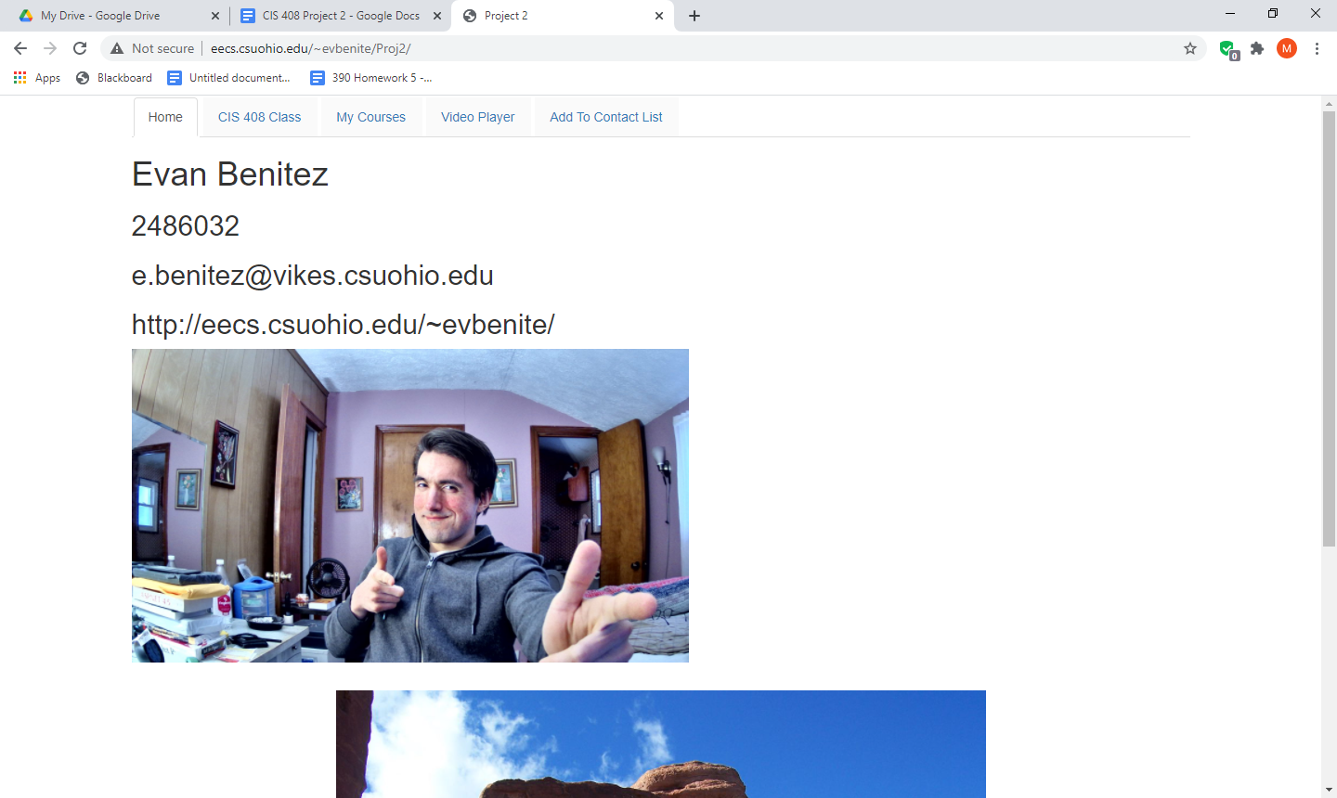

the Home tab

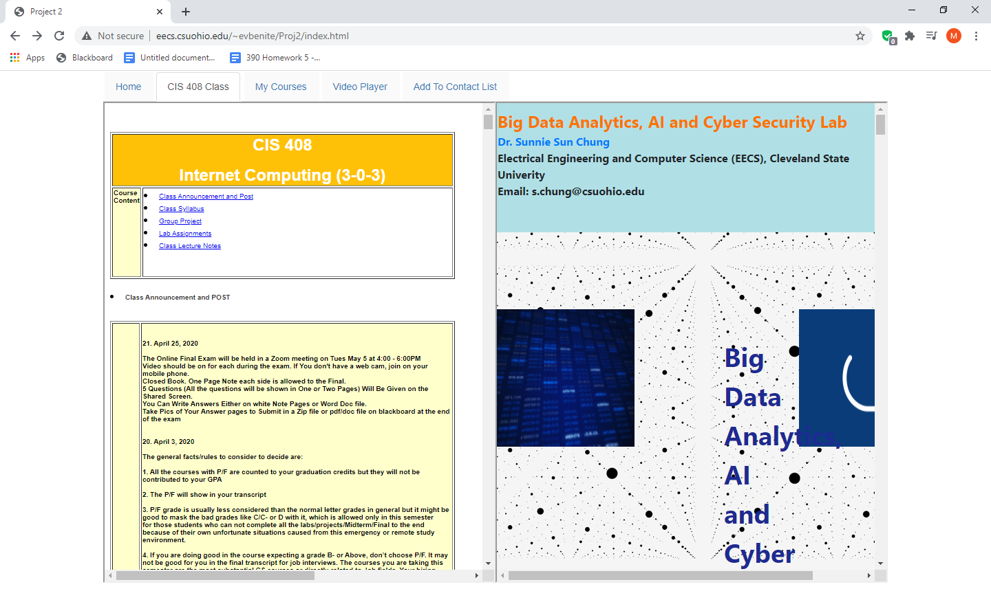

CIS 408 Class tab

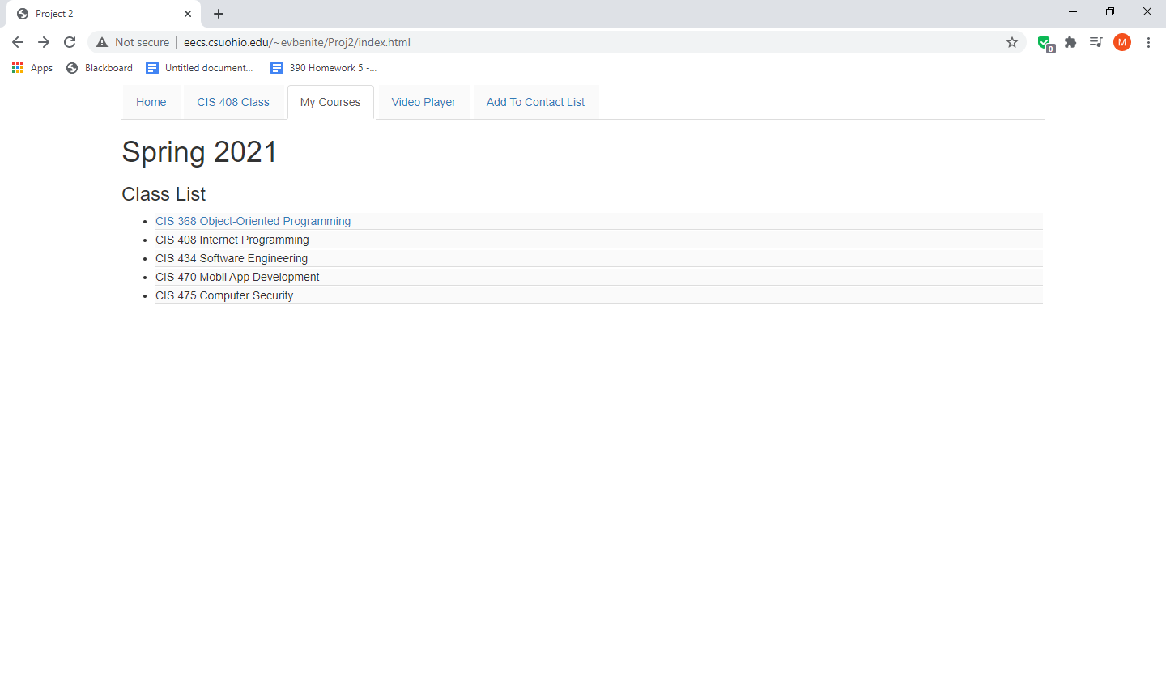

My Courses Tab

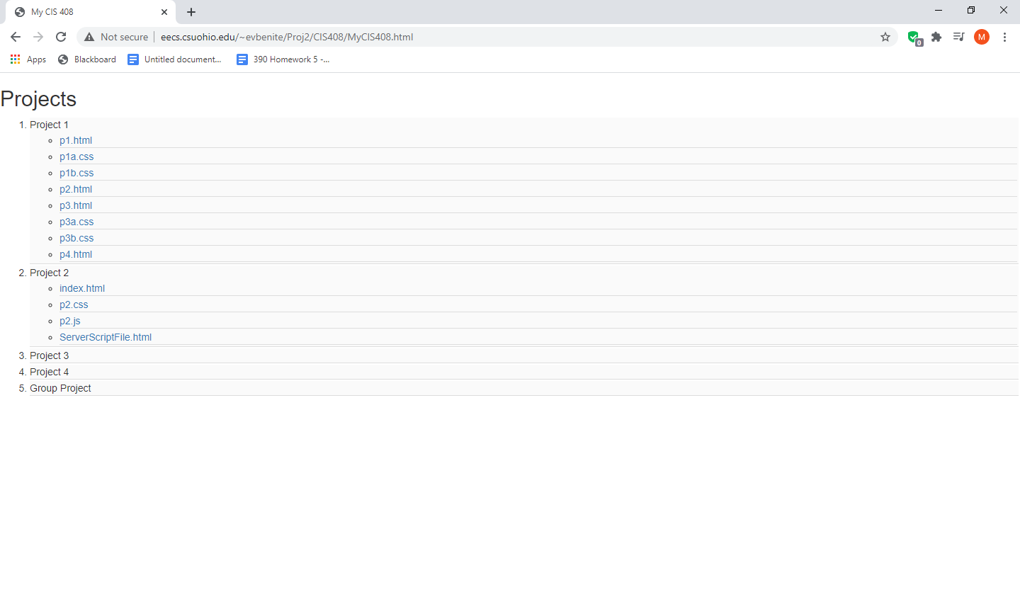

Project Page

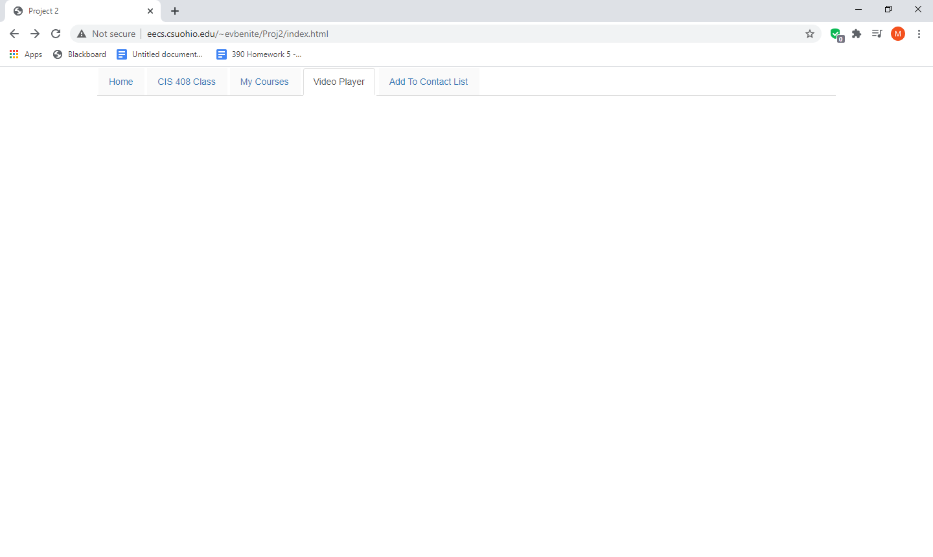

Video Player buttons not visible (Video was not uploaded per instructions)

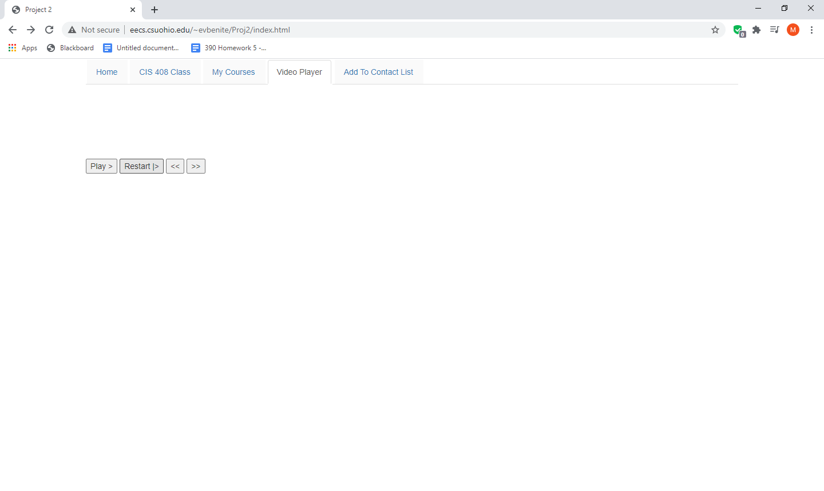

Buttons visible

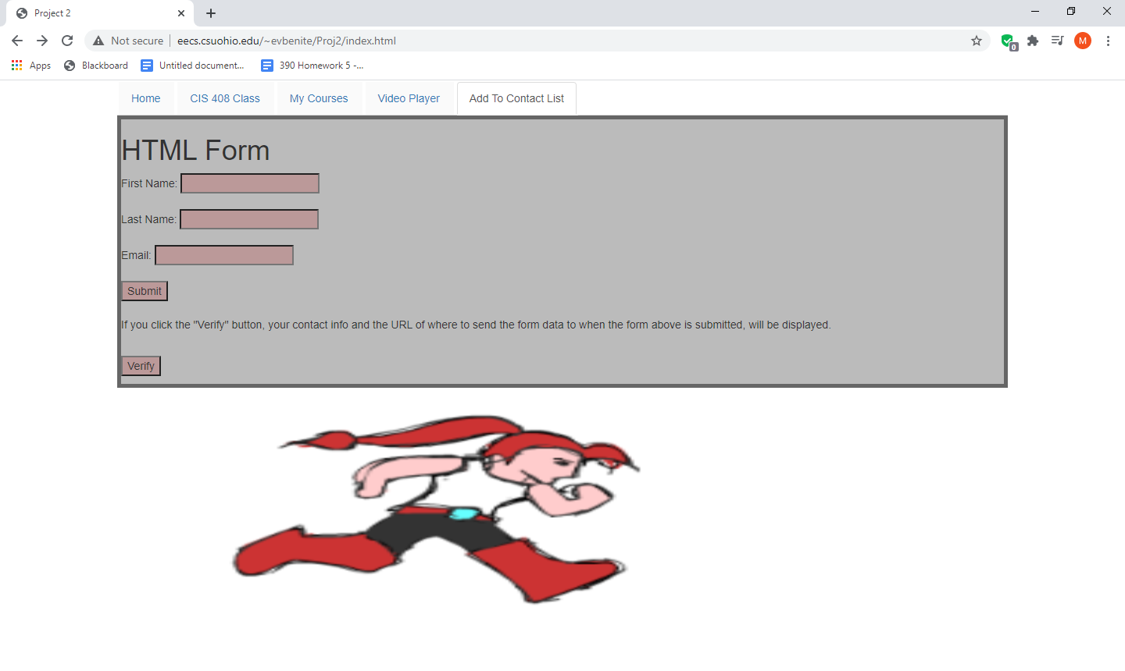

Add to Contact list tab (with animation)

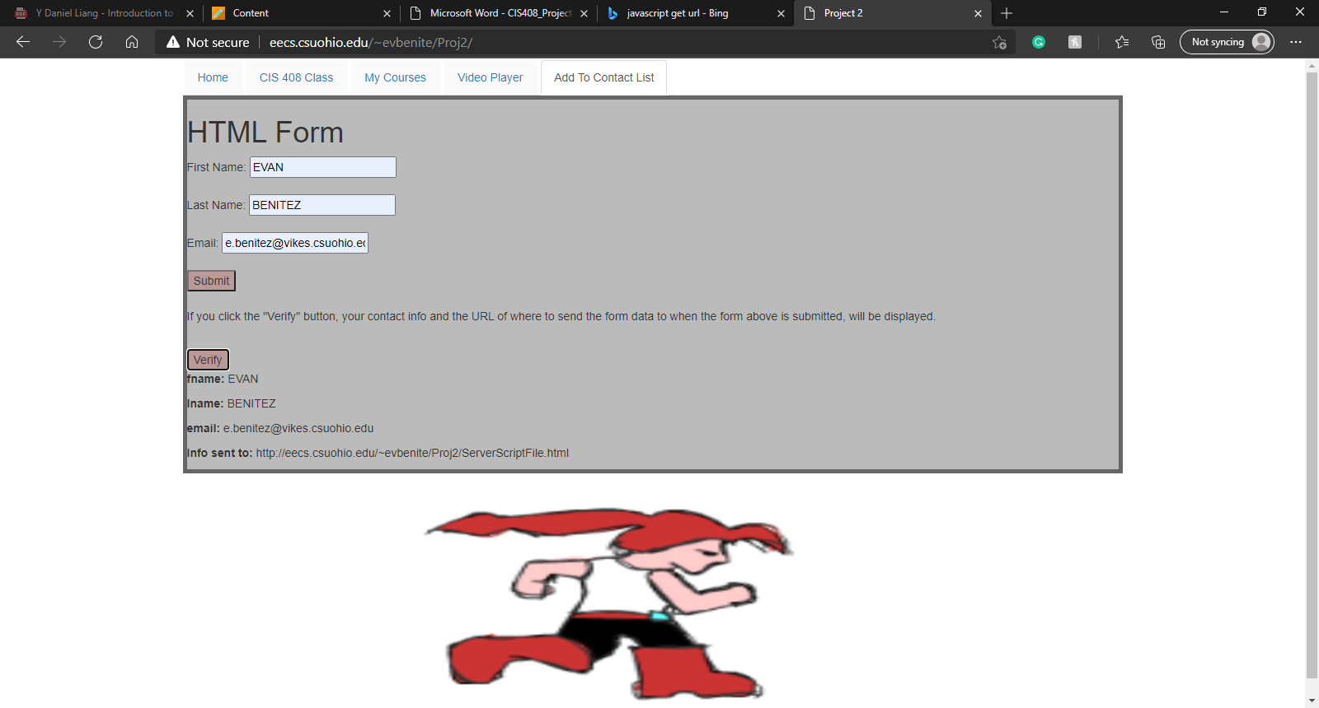

With verification

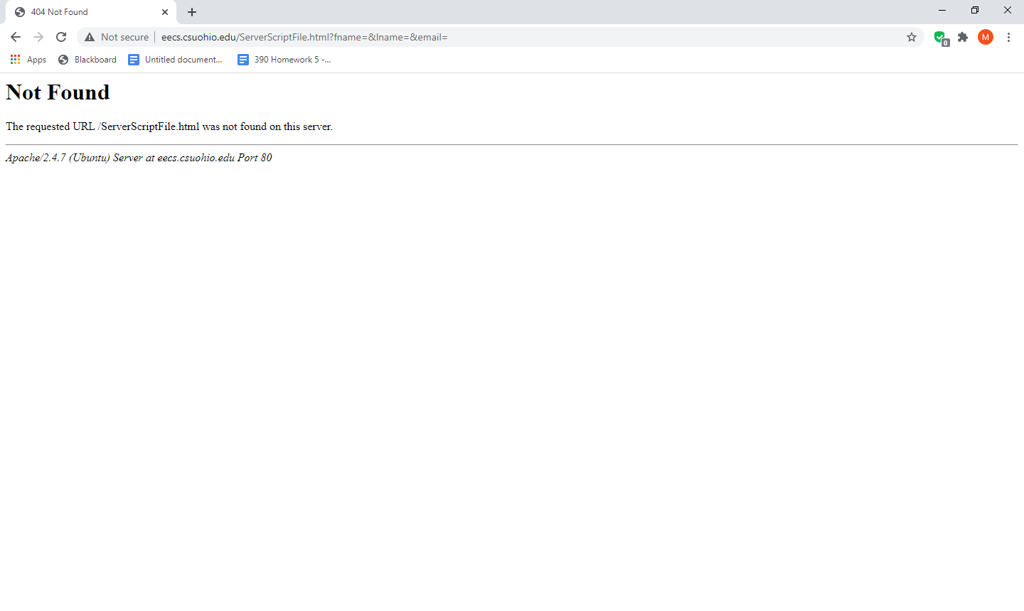This is what is displayed with “/ServerScriptFile.html”. This is because it takes you back to the root directory, which is not the directory of “ServerScriptFile.html”

**URL Query parameters**

http://eecs.csuohio.edu/~evbenite/Proj2/ServerScriptFile.html?fname=Evan&lname=Benitez&email=e.benitez%40vikes.csuohio.edu

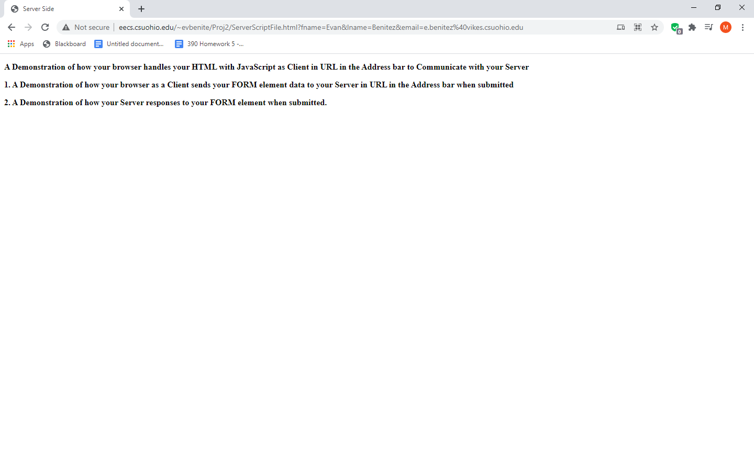

Functioning ServerScriptFile.htm

**p2.css**

li {

margin: 2px;

background-color: #fafafa;

border-bottom: 1px solid #dddddd;

}

li.active {

border: none;

background: inherit;

border-bottom: 1px solid white;

}

.wrapper {

display: flex;

flex: 100%;

flex-wrap: wrap;

}

iframe {

width: 100%;

height: 700px;

}

table.frame {

width: 100%;

}

.controls {

height: 27px;

width: 210px;

}

.buttoncontrols {

visibility: hidden;

}

.controls:hover .buttoncontrols{

visibility: visible;

}

.slide {

display: none;

padding-top: 30px;

}

.image {

width:100%;

max-width: 700px;

display: block;

margin-left: auto;

margin-right: auto;

}

.next, .back {

cursor: pointer;

position: absolute;

color: black;

font-weight: bold;

font-size:24px;

}

.next {

right: 45%;

}

.back {

left: 45%

}

#thebox {

border: 5px solid #666666;

background-color: #bbbbbb;

}

#contact input, #contact button {

background-color: #bb9999;

}

**p2.js**

var slideIndex=2;

var running=false;

//video play functions

function playVideo() {

var myVideo = document.getElementById("eagle");

var pButton = document.getElementById("pbutton");

var controlwidth = document.querySelector('.controls');

if(myVideo.paused) {

myVideo.play();

controlwidth.style.width = "222px";

pButton.innerHTML = "Pause ||";

}

else {

myVideo.pause();

controlwidth.style.width = "210px";

pButton.innerHTML = "Play >";

}

}

function restart() {

var myVideo = document.getElementById("eagle");

myVideo.currentTime = 0;

}

function back() {

var myVideo = document.getElementById("eagle");

myVideo.currentTime = myVideo.currentTime - 10;

}

function forward() {

var myVideo = document.getElementById("eagle");

myVideo.currentTime = myVideo.currentTime + 10;

}

// video play functions end here

// Start the slide show

function startSlides() {

var slides = document.getElementsByClassName("slide");

slides[slideIndex].style.display = "none";

slideIndex++;

if(slideIndex > 2){

slideIndex = 0;

}

slides[slideIndex].style.display = "block";

setTimeout(startSlides,3000);

}

// Display form data

function showInfo() {

var form = document.getElementById("formData").getElementsByTagName("input");

var data = document.getElementById("data").getElementsByTagName("p");

data[0].innerHTML = "<b>" + form[0].getAttribute("name") + ": </b>" + form[0].value;

data[1].innerHTML = "<b>" + form[1].getAttribute("name") + ": </b>" + form[1].value;

data[2].innerHTML = "<b>" + form[2].getAttribute("name") + ": </b>" + form[2].value;

data[3].innerHTML = "<b>Info sent to: </b>" + window.location.href + document.getElementById("formData").getAttribute("action");

}

//animation script

async function runAnimation() {

var i=0;

var x=0;

var sketch = document.getElementById("runner").getContext("2d");

var imgArray = [];

sketch.fillStyle="#ffffff";

for(var j=1; j <= 5; j++) {

var pic = new Image();

pic.src="imageset/run-" + j + ".png";

imgArray.push(pic);

}

// To only start the animationg once

// setInterval Used to control speed

if(running == false){

running = true;

setInterval(draw,100);

}

function draw() {

sketch.fillRect(0,0,300,150);

sketch.drawImage(imgArray[i],10,10,190,190,x,0,150,150);

i += 1;

x +=15

if(i>4){

i=0;

}

if(x>350){

x=-150;

}

}

}